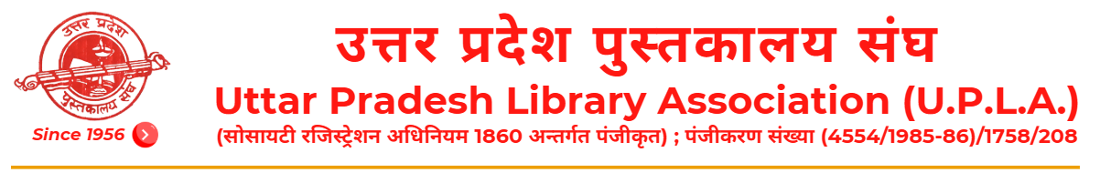

Appeal for Financial Support

The Uttar Pradesh Library Association (U.P.L.A.), Lucknow, has been tirelessly working for the promotion of library services, LIS education, and literacy awareness in society. The Association is committed to supporting library professionals, students, researchers, and libraries through various academic and social initiatives.  To continue these activities successfully and to strengthen its library services, including library automation, publication of journal, newsletter, conference proceedings etc and other developmental works, the Association requires financial assistance and public support.  We earnestly appeal to all well-wishers, institutions, organizations, and individuals to come forward and contribute generously to this noble social cause. Your valuable donation will help us in enhancing library resources, improving services, and promoting education and literacy in the community.  Every contribution, big or small, will make a meaningful difference.  We look forward to your kind support and cooperation. | Our Esteemed Contributors:
  Name of the Doner | Amount (Rs.)
  Dr Umesh Chandra Rastogi,  Former, Vice President, U.P.L.A., Lucknow | 11000.00
  Dr. Subhas Chandra Tyagi,  Retired Librarian, Lajpat Rai College, Sahibabad | 11000.00
  Ms. Meenakshi Saxena,  Retired Assistant Commissioner, Sales Tax, Lucknow | 2100.00
  Dr. V. N. Tripathi,  Former Librarian, Narayan PG College, Shikohabad | 11000.00
  Sh. Ajay Srivastava,  Retired, Vice President, DIMTS, Delhi | 5000.00
  Dr. S. B. Kulshreshtha,  Former Librarian, M.M.H. College, Ghaziabad | 51000.00
  Prof. R. L. Raina,  Vice Chancellor, Jaipur National University, Jaipur | 50000.00

Donation is accepted only through Online Mode or Demand Draft only.

Donation Details: ☐ Online ☐ Demand Draft
Bank Details | Demand Draft
Beneficiary Name: Uttar Pradesh Library Association  Account Number:000200300010582  IFSC Code: UPCB0000002  Bank & Branch Name: 14, Vidhan Sabha Marg, Lalbagh, Lucknow,  Uttar Pradesh, 226001 | The Demand Draft must be in favour of ‘Uttar Pradesh Library Association payable at Lucknow.
Transaction No./UTR/ Demand Draft No. __________________________ Date: ____________________
(Please attach a copy of Transaction and inform the general secretary via email or letter)

Address:
Vinod Kumar Mishra,  General Secretary,  Uttar Pradesh Library Association (U.P.L.A.)  Khasra No.53, Mirjapur Ajnahar Road,  Behind AKTU, Jankipuram Extension,  Lucknow-226031, Uttar Pradesh, INDIA  Mob.: +91 8707762652; +91 9415087848;  E-mail: uplageneralsecretary@gmail.com | fouksn dqekj feJk]  egkea=h]  mÙkj çns'k iqLrdky; la?k]  [kljk la[;k 53] fetkZiqj&vtagkj jksM]  ,dsVh;w ds ihNs] tkudhiqje ,DlVsa'ku]  y[kuÅ&226031] mÙkj çns'k] Hkkjr  eksckby% +91 8707762652, +91 9415087848  Ã&esy% uplageneralsecretary@gmail.com

